Please read carefully the Terms of Use for the Community Room

We are glad to share with you the use of our facilities at Woden Community Service. For the use of these facilities to continue for all it is important that we treat these rooms with respect and care as best we can.
Please sign and return this document to reception.
When using the Community Room you agree to the following:

- Security Key: When hiring a room outside of our opening hours you will be issued with a security card and building key. Please return the card and key on the next business day after your booking, unless otherwise arranged with WCS staff. Should you lose this key a $50 charge will be issued to you for the replacement of the key, and access to the Community Room may be revoked until the key has been either returned or replaced.

- Equipment and Furniture: You must agree to treat the equipment and furniture in this room with respect and care. Should any damages occur you may be charged with the repair or replacement cost of damaged property. You must report any damages found or arisen accidental or otherwise to a staff member as soon as possible.

- Housekeeping: When using our facilities please remember to clean up afterwards, always trying to make sure you leave a room as you found it. If the room is untidy - please report this to a staff member as soon as possible.

- Use of the Community room and access to adjacent rooms: When using the Community Room please do not enter into the reception office area, or to other rooms which may be left open. Please keep access only to the bathroom areas and the community room unless otherwise directed by WCS staff.

- Time in / time out: When using the Community Room please keep to the established booking time. Holding the room over your hire period may clash with other people’s use of the room, with our staffs need for the room, or the cleaning of the facility. You may be charged for rescheduling these activities or for the extra time used.

- In the event of an Emergency – If there is a fire, evacuate the building through the signed fire escape doors and rally at the underpass outside of the Lollipop Day Care Centre. Contact emergency services as soon as possible.

- Emergency contact: In the event of an emergency always contact #000 immediately. If there is a problem with the Community Room you can contact the Facility Coordinator, or for security needs please call SecurityOne our security provider.

Facility Coordinator | Dayne Matatia | 0459 878 981 | dayne.matatia@wcs.org.au
SecurityOne | 02 6122 2777 – 136 000 24hr Service

Below is a copy of the evacuation diagram – for further information please see a WCS staff member.
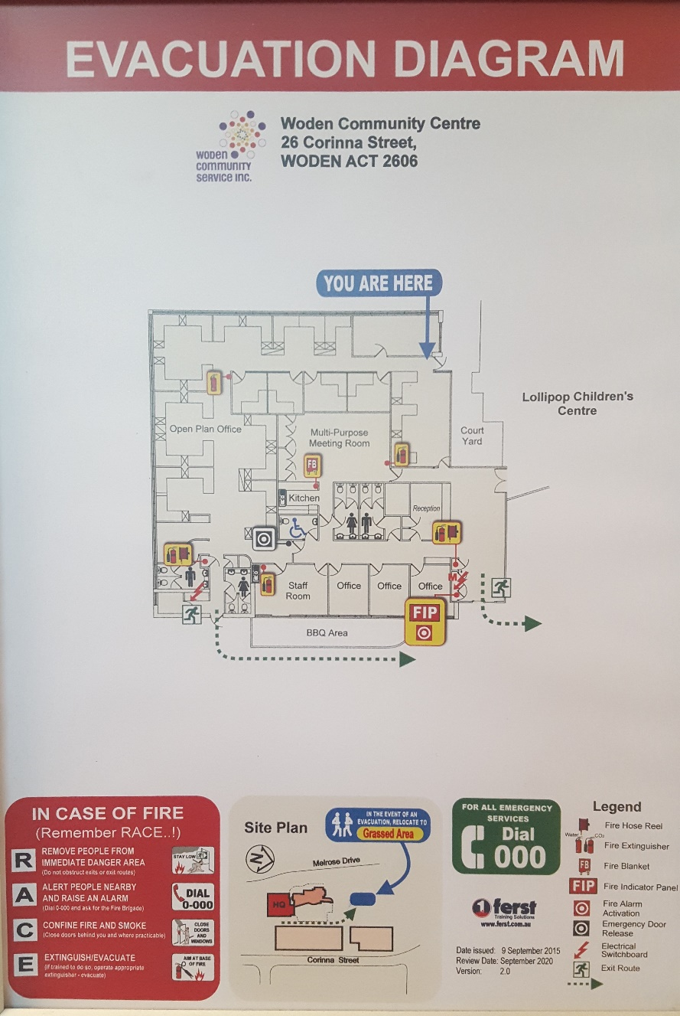

Community Room Hire
Organisation Name |  |  | ABN
Booking Date  (dd/mm/yyyy) |  |  | Time
Purpose of Hire / Use
Contact Details
Name
Telephone No. |  |  | Email
Postal Address | No.| Street
City |  | Post Code |  | State

Booking is Confirmed | Yes No |  | Yes No
Booking is Confirmed | Yes No |  | Yes No

Room Hire Rates
Purpose of Use/ Hire | Session | Weekdays | Saturday / Sunday
Community Use | Per 1 Hour Session | $ 30.00 | $ 33.00
 | Per 3 Hour Session | $ 75.00 | $ 82.50
 | Per 1 Day Session | $ 130.00 | $ 135.00
Commercial Use | Per 1 Hour Session | $ 45.00 | $ 50.00
 | Per 3 Hour Session | $ 120.00 | $ 125.00
 | Per 1 Day Session | $ 210.00 | $ 230.00

** Please note: The above prices are GST inclusive.

Thank you.

WODEN COMMUNITY SERVICES INC.

26 CORINNA STREET WODEN

PO BOX 35 WODEN 2606

TEL: 02 6282 2644

FAX: 02 6285 1322

